INVITATION LETTER
Young People with Intellectual Disability

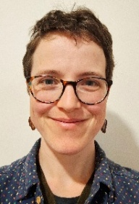 | Hello!  My name is Sierra  I am a PhD student at UNSW
 | This is an invitation for you to take part  in a research project research project called In Their Own Words
 | Research means  - finding out what people think about things  - using the information to help other people
 | You can ask someone you know and trust to help you understand this letter

What is this project about
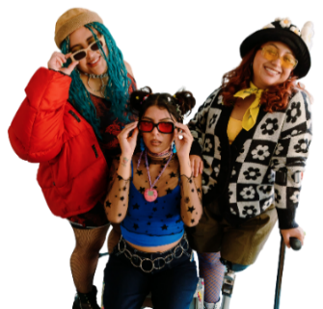 | This project is about young people with intellectual disability
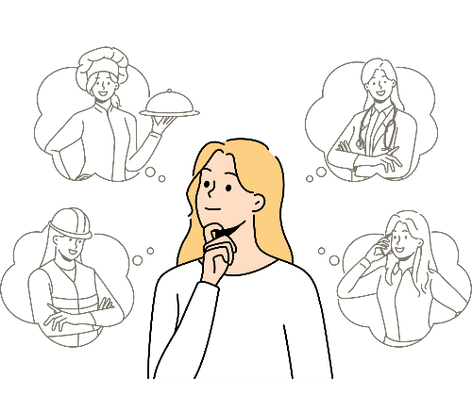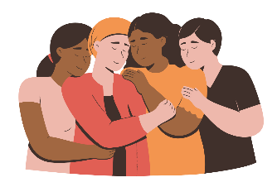 | I want to learn about young people’s experiences as they  - grow up  - make big decisions  - become adults  - stand up for themselves  - ask for support and respect

Who I want to talk to
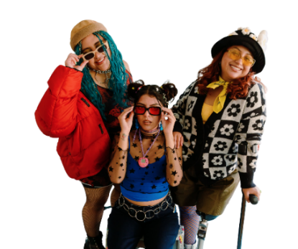 | People with intellectual disability who  - are 12 to 28 years old  - live in Australia  - speak English
What will happen
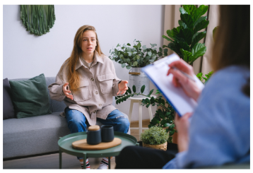 |  | You can decide to  - do an interview with me  - do an interview and a photo activity to help tell your story
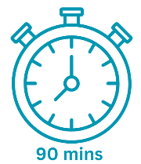  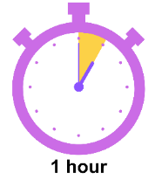 |  | The interview takes about 1 hour  If you do the photo activity as well it takes about 90 minutes
    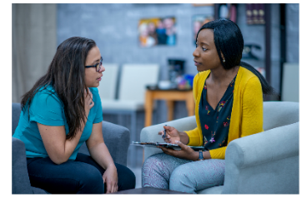   |  | The interview can be  - in person  - on Teams  - on Zoom  - over the phone
 |  | You can choose a support person like a  - a parent or  - a friend  to join you
  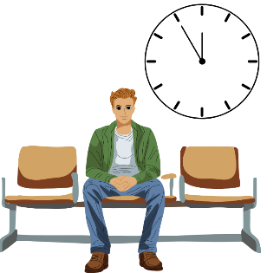 |  | If you are 12 to 17 years old you must bring an adult support person  Your can choose if your support person  - waits outside the interview  - joins you in the interview space

Find out more
 |  | If you want to learn more you can read the participant information statement and consent form
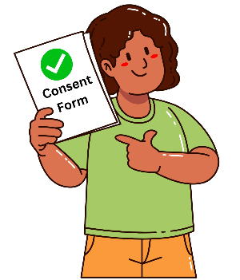 |  | The participant information statement and consent form explains  - the details of the study  - any possible risks
 |  | Please get in touch with me to  - get a copy of this form  - ask questions about the study

Our contact details
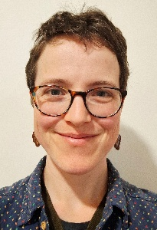 | My full name is Sierra Angelina Willow  - Phone (02) 9348 2102  - Mobile 0404 494 896  - Email s.willow@unsw.edu.au
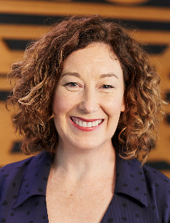 | You can also contact my supervisor  My supervisor’s name is Maree Higgins  - 02 9065 6318  - m.higgins@unsw.edu.au

